emailGen Users Manual

By Symantec Security Response

Table of Contents

0.0 Revision History 3
1.0 Scope 3
2.0 emailGen Introduction 3
3.0 emailGen Arguments 3
4.0 Screenshots 4
5.0 Error/Warning Messages 7

0.0 Revision History
Full Name | Date | Description/Comments
Sarkisian, Armond | 05/11/2005 | Created table of contents and prepared initial draft
Sarkisian, Armond | 10/10/2005 | Updated manual with new features recently implemented into emailGen

1.0 Scope
The goal of this users manual is to explain the purpose of emailGen, what purpose it serves, and how it benefits Response (AV Certification & Publication) team.

2.0 emailGen Introduction
emailGen (E-mail Generator) is a tool, which was written in C++.NET to allow the publisher to instantly generate posting emails. AV Certification team publishes AV definitions once per day excluding Emergencies. Every time an engineer publishes AntiVirus definitions, a report must be sent to all Response managers notifying them the purpose of the release. By default, Response publishes AV definitions to LU Plus (LUP), which is on the onramp2 servers, and IU (Intelligent Updaters), which is on both FTP and WWW servers. On average, it takes an engineer 4 – 6 minutes to manually create a single notification. One of the main purposes of emailGen is to decrease the time spent in creating these notifications. By having to manually create 2 – 3 E-mail notifications, one can spend at most ten minutes trying to capture the data.

3.0 emailGen Arguments
emailGen was designed to accept command-line arguments. emailGen will output the appropriate data based on the arguments it was given.

Usage: emailGen "defFolder" { [-CC] [-ALL] | [-LU] [-LUP] [-IU] [-HH] }

Arguments | Level | Purpose | Warnings
“Definition Folder” | 0 | Uses the definition folder path to parse through the virscan1.dat file and capture the DIS Sequence # and Product Version. This argument is required by emailGen and should be the first argument. | Ensure the correct path is given to emailGen when submitting the definition path. Please note that it only accepts the path and not the file itself. Do not submit the virscan1.dat file to emailGen. Once you submit the path, it will automatically locate virscan1.dat and parse through the file.
-CC | 1 | This argument will notify emailGen that there will be a custom comment (CC). Custom comments include Emergencies, Engine Releases, Rollback Builds, Missed Detection’s, FP’s, Reclassifications, and CAT 3+ Builds. | If this switch is going to be entered, it must be entered prior to all other switches excluding “Definition Folder.” The reason for this is because emailGen cannot generate the email notification and then obtain the custom comment from the user. The user *must set the –CC option first and then all other switches.
-ALL | 1 | This argument used in conjunction with the first argument ( Definition Folder ) will produce all three results including LiveUpdate, LiveUpdate Plus, and Intelligent Updaters. This will not however generate a Handheld report as HH is not done on a daily basis. | If this switch is going to be used, it must be used after the Definition Folder and [-CC] switch. Also, if using the –ALL switch, the only other switch that can be present is the –HH switch and no other switches as the –ALL switch basically takes care of everything.
-LU | 2 | This switch will trigger emailGen to generate a LiveUpdate (LU) E-mail notification. | The only error/warning associated with this switch is if you accidentally enter this switch more than once.
-LUP | 2 | This switch will trigger emailGen to generate a LiveUpdate Plus (LUP) E-mail notification. | The only error/warning associated with this switch is if you accidentally enter this switch more than once. The only error/warning associated with this switch is if you accidentally enter this switch more than once. The only error/warning associated with this switch is if you accidentally enter this switch more than once.
-IU | 2 | This switch will trigger emailGen to generate an Intelligent Updater (IU) E-mail notification. | The only error/warning associated with this switch is if you accidentally enter this switch more than once.
-HH | 2 | This switch will trigger emailGen to generate a Handheld (HH) E-mail notification. Using this switch will prompt you to enter a sequence number for the Palm definitions. | The only error/warning associated with this switch is if you accidentally enter this switch more than once.
*Level field sets the priority order in which you should enter the switches

4.0 Screenshots

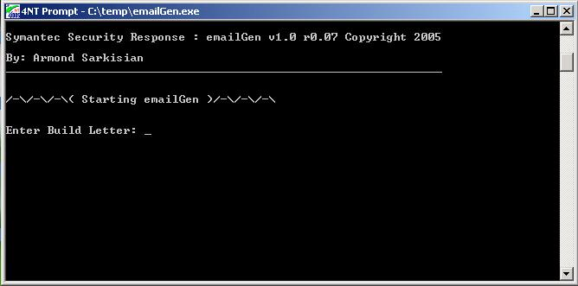
Figure 4.0: Initial emailGen screen, which prompts the user to enter the DBCS build letter

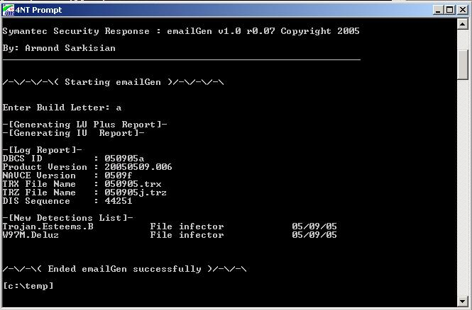
Figure 4.1: emailGen successfully completed a run. Displays all the DBCS information

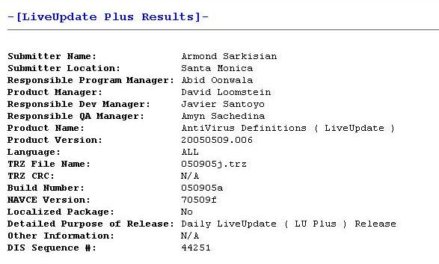
Figure 4.2: emailGen generated HTML log file for LiveUpdate Plus (LUP)

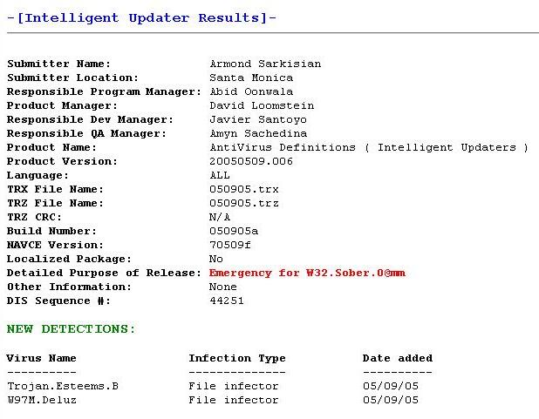
Figure 4.3: emailGen generated HTML log file for Intelligent Updaters (IU) with Custom Comment (-CC)

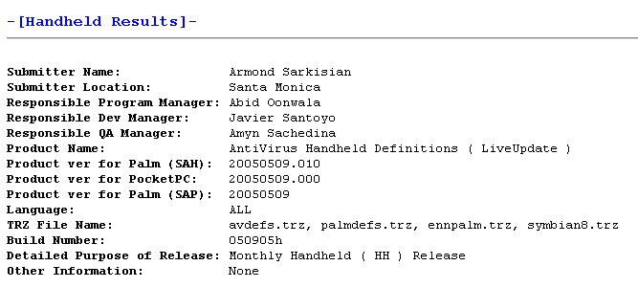
Figure 4.4: emailGen generated HTML log file for Handheld (HH)

5.0 Error/Warning Messages

Error/Warning | Description | Severity
Error 100 | Not enough arguments, please try again! | Low
Error 101 | Too many arguments, please try again! | Low
Error 102 | Invalid option, please try again! | Low
Error 103 | Definition Path does not exist! | High
Error 104 | Write protection error, cannot write to file! | High
Error 105 | LU Template does not exist, please create one! | High
Error 106 | LU Plus Template does not exist, please create one! | High
Error 107 | IU Template does not exist, please create one! | High
Error 108 | Cannot specify the same option multiple times! | Low
Error 109 | Switches (-cc) are not in order, please try again! | Low
Error 110 | Invalid DBCS ID, please try again! | Medium
Error 111 | Definition file does not exist under the given path! | High
Error 112 | Error reading from definition file! | High
Error 113 | Definition file is corrupt! | Critical
Error 114 | Cannot write to log file! | High
Error 115 | Updates file does not exist in definitions directory! | Medium
Error 116 | Error reading from updates file! | High
Error 117 | DIS Sequence number is not unique! | High
Error 118 | HH Template does not exist, please create one! | High
Warning 100 | No new detections added, please verify manually! | Very Low
Unknown Error | Unknown internal error! | Critical
*Severity is based on Very Low, Low, Medium, High, and Critical

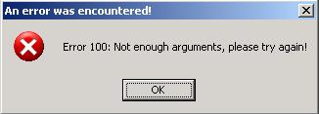
Figure 5.0: Error 100: Not enough arguments, please try again!

